**UPMSAT-3 Thermal Control Subsystem**

|  |  |
| --- | --- |
| Prepared by | Thermal Team |
| Approved by | System Engineering team |
| Reference |  |
| Issue | 003 |
| Revision | 01 |
| Date of issue | 30 May 2024 |

**DISTRIBUTION LIST**

|  |  |  |  |
| --- | --- | --- | --- |
| **NAME** | **ORG.** | **NAME** | **ORG.** |
|  |  |  |  |
|  |  |  |  |
|  |  |  |  |
|  |  |  |  |
|  |  |  |  |

**LIST OF CHANGES**

|  |  |  |  |
| --- | --- | --- | --- |
| **Reasons for the change** | **Issue** | **Revision** | **Date** |
|  |  |  |  |

CONTROL

|  |  |
| --- | --- |
| Prepared by: Thermal Team | Approved by: System Engineering team |
|  |  |
|  |  |
| Date: 30 May 2024 | Date: |

TABLE OF CONTENTS

1 Scope 5

2 Applicable Documents 5

3 Reference documents 5

4 List of acronyms and abbreviations 7

5 Geometrical Mathematical Model (GMM) 8

5.1 Thermo-optical properties 9

6 TMM 11

6.1 General assumptions applied to TMM 11

6.2 Operation modes and dissipation of each instrument and payload 11

6.3 Material properties 12

6.4 Orbit & Environment 14

6.5 Radiative and analysis cases 15

7 Results 16

7.1 Latency 16

7.2 Nominal 18

7.3 Payload 1 21

7.4 Payload 2 24

7.5 Safe 26

7.6 Battery comparison cases 29

8 Components Temperature Range 30

9 GL scheme 31

TABLE OF FIGURES

Figure 1: 3D and ESATAN-TMS models. 8

Figure 2: Structure, instruments, and payload ESATNA -TMS models 8

Figure 3: Distribution of the thermo-optical properties (I). 9

Figure 4: Distribution of the thermo-optical properties (II). 10

Figure 5: Thermo-optical properties distribution (III). 10

Figure 6: Thermo-optical coatings (I). 12

Figure 7: Thermo-optical coatings (II). 13

Figure 8: Thermo-optical coatings (III). 13

Figure 9: Orbit of UPMSAT 3 and Heat Flux. 14

Figure 10: Temperature of instruments in latency ops. mode. 16

Figure 11: Temperature of payloads in latency operations mode 16

Figure 12: Temperature of Solar Panels in latency ops. mode. 17

Figure 13: Temperature of Lateral panels in latency ops. mode. 17

Figure 14: Temperature of Trays in latency ops. mode. 18

Figure 15: Temperature of instruments and payloads in nominal ops. mode. 18

Figure 16: Temperature of payloads in nominal operations mode 19

Figure 17: Temperature of Solar Panels in nominal ops. mode. 19

Figure 18: Temperature of Lateral Panels in nominal ops. mode. 20

Figure 19: Temperature of Trays in nominal ops. mode. 20

Figure 20: Temperature of instruments in payload 1 ops. mode. 21

Figure 21: Temperature of payloads in payload 1 ops. mode. 21

Figure 22: Temperature of Solar Panels in payload 1 ops. mode. 22

Figure 23: Temperature of Lateral Panels in payload 1 ops. mode 22

Figure 24: Temperature of Trays in payload 1 ops. mode. 23

Figure 25: Comparison of radiative cases with BF-UC3M. 23

Figure 26: Temperature of instruments in payload 2 ops. mode. 24

Figure 27: Temperature of payloads in payload 2 ops. mode. 24

Figure 28: Temperature of Solar Panels in payload 2 ops. mode. 25

Figure 29: Temperature of Lateral Panels in payload 2 ops. mode. 25

Figure 30: Temperature of Trays in payload 2 ops. mode. 26

Figure 31: Temperature of Instruments and payloads in safe ops. mode. 26

Figure 32: Temperature of Instruments and payloads in safe ops. mode. 27

Figure 33: Temperature of Solar Panels in Safe ops. mode. 27

Figure 34: Temperature of Lateral Panels in Safe Ops. mode. 28

Figure 35: Temperature of Trays in Safe ops. mode. 28

Figure 36: Battery comparison cases. 29

Figure 37: GL scheme of the UPMSat-3 ESATAN-TMS model. 31

TABLE OF TABLES

Table 1: Thermo-optical properties. 9

Table 2: Dissipation of each instrument and payload depending on the operation mode. 11

Table 3: Materials and properties. 12

Table 4: Orbital parameters at the beginning of the orbit. Date: 2025-01-01 12:00. 14

Table 5: Value of the different parameters to estimate STEM. 15

Table 6: Parameters of the STEM 15

Table 7: Analysis cases. 15

Table 8: Operational and Survival temperature range. 30

# Scope

The aim of this document is to describe the thermal environment, the analysis of the system, and the applied thermal control to meet the requirements.

# Applicable Documents

The following documents are applicable to the development of this plan:

|  |  |
| --- | --- |
| [AD1] | ECSS-E-HB-31-03A – Thermal analysis handbook. ESA-ESTEC,2016 |
| [AD2] | ECSS-E-HB-32-23A – Threaded fasteners handbook. ESA-ESTEC,2016 |

# Reference documents

The following documents are references to the development of this plan:

|  |  |  |  |  |  |  |  |  |  |  |  |  |  |  |  |  |  |  |  |  |  |  |  |  |  |  |  |  |  |  |  |  |  |  |  |  |  |  |  |  |  |  |  |  |  |  |  |  |  |  |  |
| --- | --- | --- | --- | --- | --- | --- | --- | --- | --- | --- | --- | --- | --- | --- | --- | --- | --- | --- | --- | --- | --- | --- | --- | --- | --- | --- | --- | --- | --- | --- | --- | --- | --- | --- | --- | --- | --- | --- | --- | --- | --- | --- | --- | --- | --- | --- | --- | --- | --- | --- | --- |
| |  |  | | --- | --- | | [R01] | David G. Gilmore. Spacecraft Thermal Control Handbook. Volume I: Fundamental  Technologies. The Aerospace Press, 2002 | | [R02] | ATHENA: Advanced Telescope for High-Energy Astrophysics. AHEPaM: Athena High-Energy Particle Monitor. | | [R03] | Test Report / Test Result. Thermo-optical properties of Surtec 650. | | [R04] | [Properties of Silicon (Si), Germanium (Ge), and Gallium Arsenide (GaAs) at 300 deg K (eesemi.com)](https://eesemi.com/sigegaas.htm) | | [R05] | Ignacio Torralbo et al. Thermal Analysis of the Solar Orbiter PHI Electronics Unit. | | [R06] | The Effect Of Cathode Compositionon The Thermal Characteristics Of Lithium Ion Cells | | [R07] | Thermal Analysis of a Fast Charging Technique for a High Power Lithium-Ion Cell. | | [R08] | US3-DHV-WP3131-DW Solar Panels Schematics V03A | | [R09] | CubeWheel - ICD [v1.19] | | [R10] | CubeADCS - ICD [V3.18] | | [R11] | CS-DEV.ICD.CT.M0.0E4.4-01 CubeStar Gen1 ICD Ver.1.00 | | [R12] | NanoCom AX100 Datasheet Long-range software configurable VHF/UHF transceiver | | [R13] | Sistema de telemetría, telecomando y comunicaciones  Propuesta para el satélite upmsat3 | | [R14] | Transceiver Module ICD Hydra Space | | [R15] | C.G. Justus and G.W. Batts. Simple Thermal Environment Model (STEM) User's Guide | | [R16] | Enbio. SolarWhite datasheet. | | [R17] | Sergio de Ávila Cabral. Test Report / Test Result. Thermo-optical properties of the structure of UPMSat-3. 2024 | | [R18] | Ahmad Khalaf Reda & Sergio de Ávila Cabral. Thermal vacuum test PCB UC3M.  IDR.LEAE - IDR, 2023. | | [R19] | Sergio de Ávila. Test Report / Test Result. Thermo-Optical Properties of DELRIN  100. Instituto de Migrogravedad Ignacio Da Riva (IDR), 2023. | | [R20] | Isidoro Martínez. ThermoOptical Properties. url: http://imartinez.etsiae.upm. es/~isidoro/. | | [R21] | Lilian Peinado Pérez. «Elaboración y Análisis del Modelo Térmico del UPMSat-2». En: (2016). | | [R22] | AzurSpace: 30 % Triple Junction GaAs Solar Cell Type: TJ Solar Cell 3G30C Advanced. | | [R23] | ASM Aerospace Specificacions Metas Inc. MatWeb. url: https://www.matweb.com/. | | [R24] | ASM Aerospace Specificacions Metas Inc. Aluminum 5052-H32. url: https://asm.matweb.com/search/SpecificMaterial.asp?bassnum=ma5052h32. | | [R25] | Midland Bright Steels. A2-70 properties. url: https://midlandbrightsteels.co.uk/a2-70/. | |  |

# List of acronyms and abbreviations

|  |  |
| --- | --- |
| GMM | Geometrical Mathematical Model |
| SSO | Sun-synchronous orbit |
| PCB | Printed Circuit Board |
| OBC | Onboard Computer |
| TMM | Thermal Mathematical Model |
| TTC | Telemetry, Telecommand and Control |
| STEM | Simple Thermal Environment Model |
| $$α_{s}$$ | Solar absorptivity |
| $$a$$ | Albedo coefficient |
| $$ε$$ | Emissivity |
| $$τ$$ | Thermal Time Constant |
| $$σ$$ | Stefan-Boltzmann constant |
| $$C_{p}$$ | Heat capacity at constant pressure |

# Geometrical Mathematical Model (GMM)

In this Section, the GMM, will be described. Figure 1 shows the 3D and ESATAN-TMS models from an outside view. Furthermore, Figure 2 illustrates the structure, instruments, and payload of the UPMSat-3.

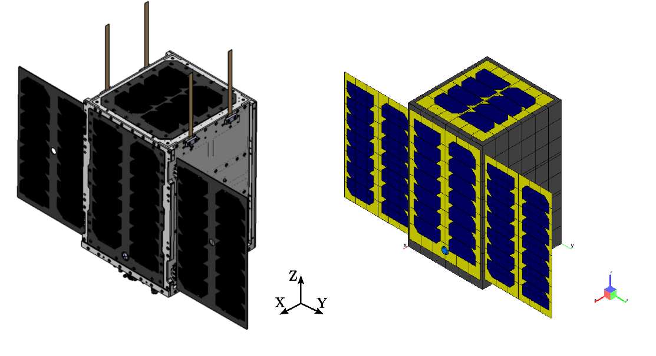

Figure 1: 3D and ESATAN-TMS models.

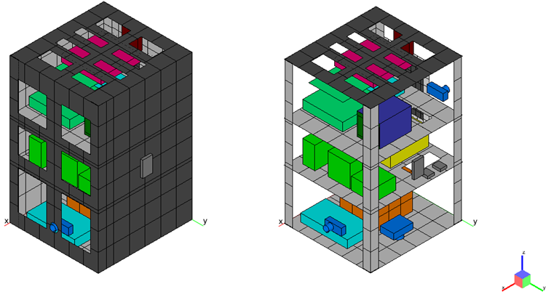

Figure 2: Structure, instruments, and payload ESATNA -TMS models

## Thermo-optical properties

The thermo-optical properties used in this model are listed in Table 1 [R01, R03, R05, R16, R17, R19]. Also, the distribution of the thermo-optical properties is shown from Figure 3 to 5.

Table 1: Thermo-optical properties.

|  |  |  |
| --- | --- | --- |
| **Thermos-optical property** | **Solar absorptivity** | **Emissivity** |
| Aluminium | 0.15 | 0.20 |
| Surtec 650 | 0.28 | 0.07 |
| Aluminised Kapton | 0.15 | 0.05 |
| CFRP + Kapton | 0.88 | 0.85 |
| CFRP | 0.83 | 0.88 |
| Solar cell | 0.63 [1] | 0.83 |
| PCB | 0.15 | 0.70 |
| DELRIN 100 | 0.52 | 0.88 |
| Black anodise | 0.67 | 0.87 |
| Enbio SolarWhite | 0.18 | 0.89 |

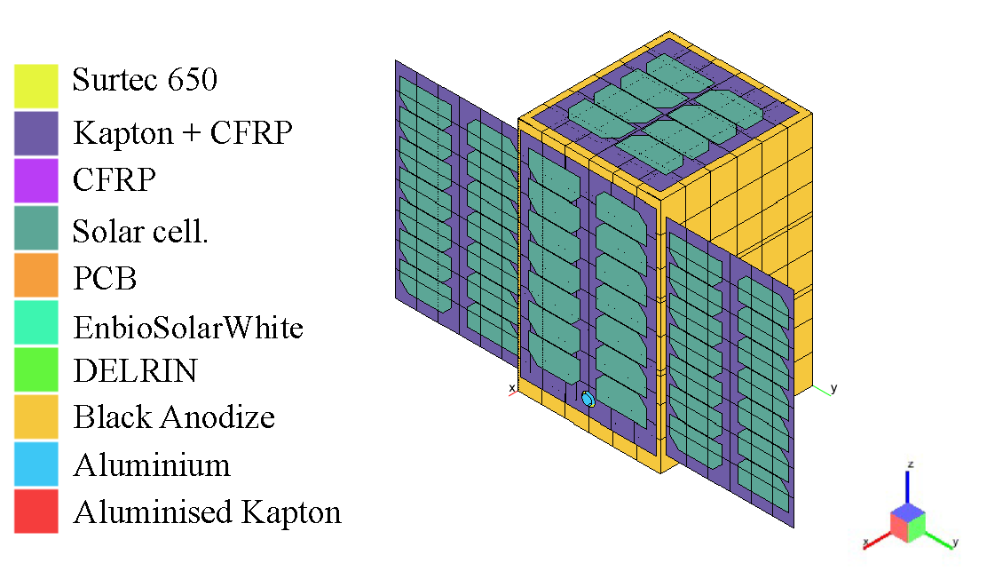

Figure 3: Distribution of the thermo-optical properties (I).

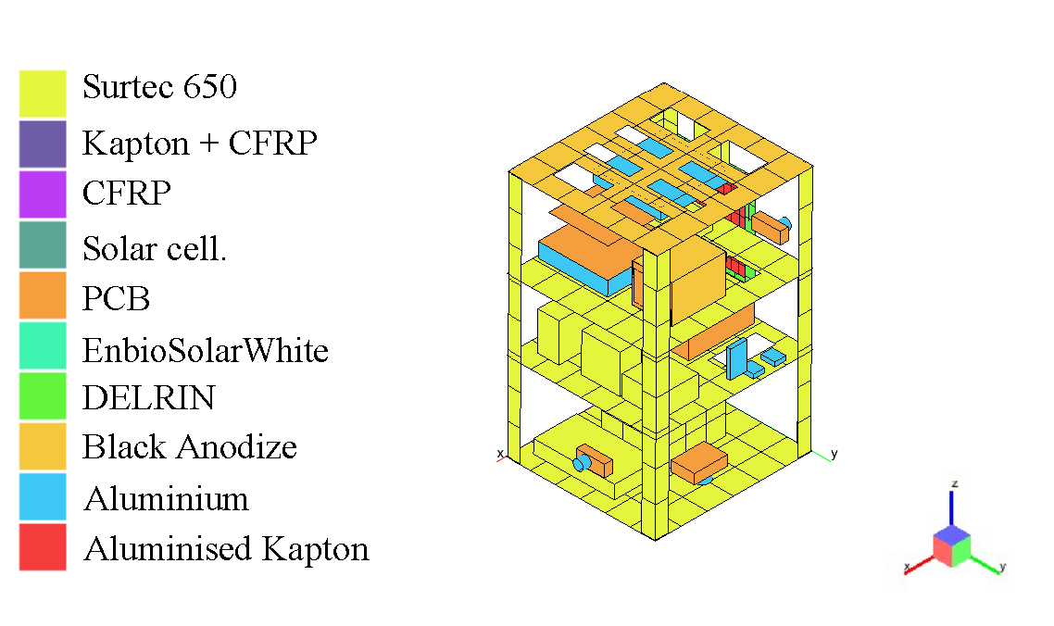

Figure 4: Distribution of the thermo-optical properties (II).

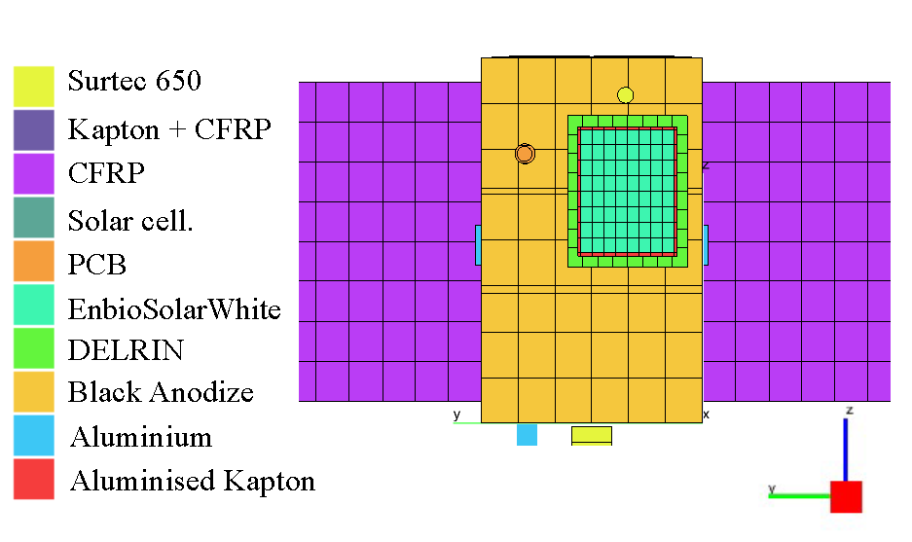

Figure 5: Thermo-optical properties distribution (III).

# TMM

In this Section, the TMM, the data, and the assumptions that are taken to simplify the modelling will be described.

## General assumptions applied to TMM

In TMM there are serial hypotheses that are considered to reduce the complexity of the GMM at the first approximation:

* If the material of a component is not defined, the bulk material will be aluminium.
* The thermal conductance in the contact zone or through conductance is $300 W/m^{2}K$ unless otherwise stated.
* Instruments whose sources of dissipation or configuration are not known shall be represented by two nodes, the geometric node and the nongeometric node, which shall have the dissipation of the instrument as the BC. Similarly, a GL = 2 W/K is assumed between the non-geometric node and the geometric node.

## Operation modes and dissipation of each instrument and payload

The operation modes and the dissipation of each instrument and payload are listened to in Table 2.

Table 2: Dissipation of each instrument and payload depending on the operation mode.

|  |  |  |  |  |  |
| --- | --- | --- | --- | --- | --- |
| **Element** | **Dissipation $\left[W\right]$** | | | | |
| **Safe** | **Nominal** | **Payload 1** | **Payload 2** | **Latency** |
| **Tray A** | | | | | |
| **Cubesense-Sun** | 0.11 | 0.11 | 0.11 | 0.11 | 0.00 |
| **Module Bat-pw** | 0.50 | 0.50 | 0.50 | 0.50 | 1.00 |
| **Startraker** | 0.15 | 0.15 | 0.15 | 0.15 | 0.00 |
| **UC3M 2** | 0.00 | 0.00 | 0.00 | 0.00 | 0.00 |
| **Ebox_UC3M** | 0.00 | 0.00 | 7.00 | 0.00 | 0.00 |
| **Tray B** | | | | | |
| **ADCS** | 2.28 | 2.28 | 2.28 | 2.28 | 0.00 |
| **Shrinkwrap 1** | 0.37 | 0.37 | 0.37 | 0.37 | 0.00 |
| **Shrinkwrap 2** | 0.37 | 0.37 | 0.37 | 0.37 | 0.00 |
| **Shrinkwrap 3** | 0.37 | 0.37 | 0.37 | 0.37 | 0.00 |
| **6U deployable SA 1** | TBD | TBD | TBD | TBD | 0.00 |
| **6U deployable SA 2** | TBD | TBD | TBD | TBD | 0.00 |
| **Magnetometer 1** | 0.07 | 0.07 | 0.07 | 0.07 | 0.00 |
| **Magnetometer 2** | 0.07 | 0.07 | 0.07 | 0.07 | 0.00 |
| **Tray C** | | | | | |
| **UC3M 1** | 0.00 | 0.00 | 0.00 | 0.00 | 0.00 |
| **BF_UC3M** | 0.00 | 0.00 | 1.00 | 0.00 | 0.00 |
| **A3200** | 3.25 | 3.25 | 3.25 | 3.25 | 0.00 |
| **IDR-AMSATEA-COMS** | 0.00 | 0.00 | 0.00 | 2.50 | 0.00 |
| **Cubesense-Nadir** | 0.11 | 0.11 | 0.11 | 0.11 | 0.00 |
| **Total** | **7.65** | **7.65** | **15.65** | **10.15** | **1.00** |

## Material properties

The properties of the material used in TMM are listed in Table 3 [R01, R04, R21, R22, R23, R24, R25]. Figure 6 to 8 show the distribution of the materials.

Table 3: Materials and properties.

|  |  |  |  |
| --- | --- | --- | --- |
| **Material** | **Density $\left[kg /m^{3}\right]$** | **Specific heat $\left[J/kg⋅K\right]$** | **Conductivity $\left[W/m·K\right]$** |
| Al-7075-T651 | 2810 | 960 | 130.00 |
| Al-6082 | 2700 | 935 | 170.00 |
| Al-6081 | 2700 | 896 | 167.00 |
| Al-5052 | 2680 | 880 | 138.00 |
| PCB | 1700 | 500 | 0.45 |
| GaAsGe | 5320 | 350 | 46.00 |
| DELRIN® 300 | 1380 | 2880 | 0.20 |
| A2-70 | 8000 | 500 | 16.20 |
| Copper | 8910 | 390 | 395.00 |
| Kapton® | 1420 | 1090 | 0.20 |
| Solar Panels Support | 1550 | 711 | 5.00 |

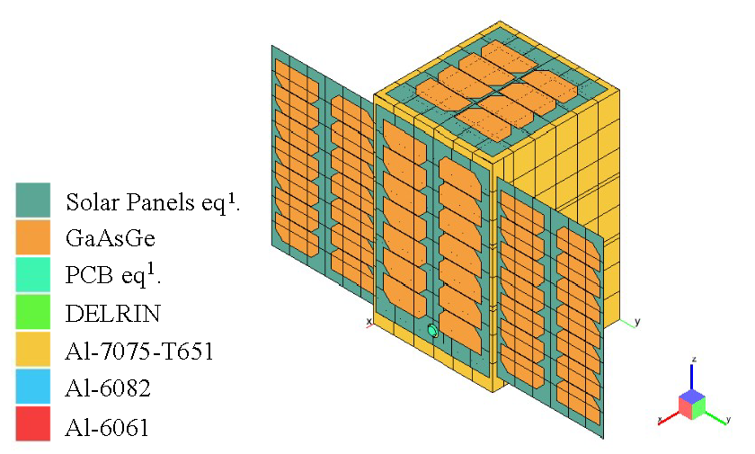

Figure 6: Thermo-optical coatings (I).

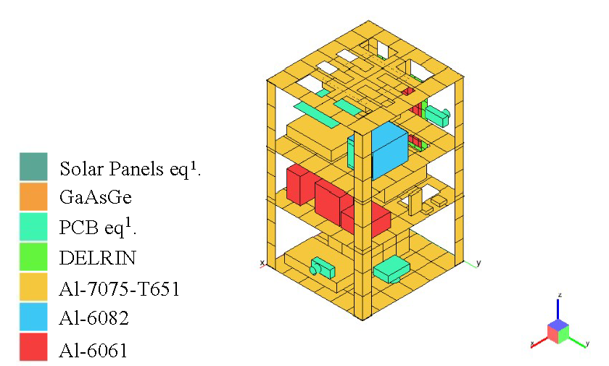

Figure 7: Thermo-optical coatings (II).

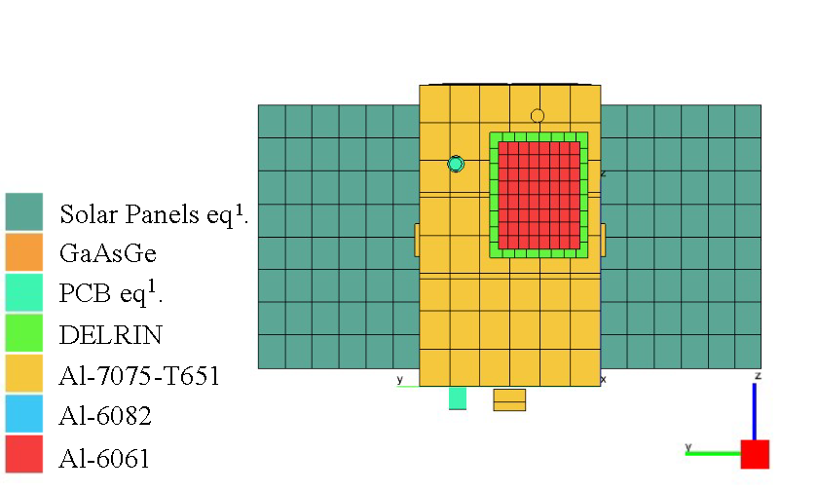

Figure 8: Thermo-optical coatings (III).

## Orbit & Environment

The orbit of UPMSAT-3 is an SSO. Its parameters are shown in Table 4:

Table 4: Orbital parameters at the beginning of the orbit. Date: 2025-01-01 12:00.

|  |  |
| --- | --- |
| **Orbit parameters** | **Value** |
| Semimajor axis [km] | 6928 |
| Eccentricity | 0.001 |
| Inclination [deg] | 97.405 |
| RAAN [deg] | 79.812 |
| Argument of the Perigee [deg] | 0.0 |
| True anomaly [deg] | 0.0 |
| Primary pointing vector (Zenit) | $$\left[0.985, 0.0, -0.174\right]$$ |
| Secondary pointing vector (Normal to orbit) | $$\left[0.174, 0.0, 0.985\right]$$ |

This orbit is shown in Figure 9, where the heat flux over the UPMSAT-3 can also be seen.

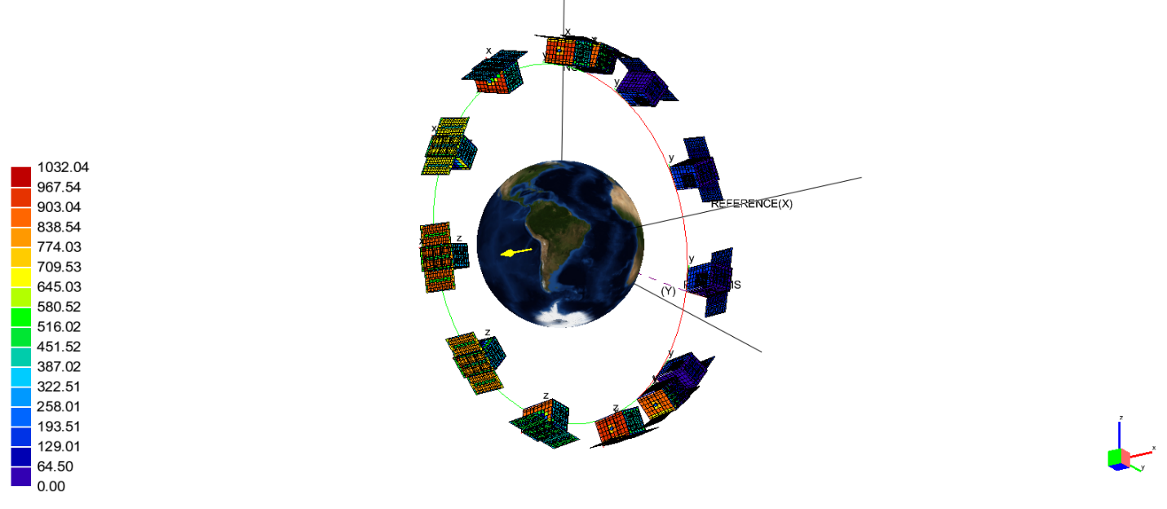

Figure 9: Orbit of UPMSAT 3 and Heat Flux.

Following [R15], a STEM can be performed. The orbit of UPMSAT-3 has a $β$ angel of 22.5°. $τ$ can be calculated by the following equation:

|  |  |  |
| --- | --- | --- |
|  |  |  |
|  | $$τ=\frac{M C_{p}}{4 A ε σ T_{0}^{3}}$$ | (1) |
|  |  |  |

Where $A$ is the area of the most representative geometry, $ε$ is the emissivity of that geometry, $M$ is the mass and $T_{0}$ is an estimated average temperature of that geometry. The representative geometry is the Lateral Panel X $-$, which is continuously looking to Nadir. The values of these parameters are listed in Table 5.

Table 5: Value of the different parameters to estimate STEM.

|  |  |
| --- | --- |
| **Parameter** | **Value** |
| Mass [kg] | 0.465 |
| $Cp$ [J / kg K] | 960 |
| $A$ [$m^{2}$] | 0.0834 |
| $$ε$$ | 0.0483 |
| $T_{0}$ [K] | 309.5 |
| $τ$**[Hour]** | 6.0 |
| $τ/4$**[Minutes]** | 90.0 |

Calculated $τ$ and $τ/4$, from Table 2.3 of [R15] can be obtained the Albedo and OLR values. Also, the albedo correction must be taken into account as a result of the inclination of the orbit. In this orbit, the correction is $c=0.056$. Table 6 lists the estimated parameters for STEM.

Table 6: Parameters of the STEM

|  |  |  |
| --- | --- | --- |
| **Parameter** | **Case** | |
| **Cold** | **Hot** |
| Albedo | 0.226 | 0.336 |
| OLR $\left[W/m^{2}\right]$ | 218 | 259 |
| T [K] | 249 | 260 |

## Radiative and analysis cases

As described in Section 6.4, a characterisation of the thermal space environment. This process defines two out of three radiative cases:

* *Cold* case: Radiative case defined by the cold conditions obtained in STEM.
* *Standard* case: Radiative case defined by predefined thermal space conditions in ESATAN-TMS ( $T=254.3 K$ and $a=0.306$).
* *Hot* case: Radiative case defined by the hot conditions obtained in STEM.

Moreover, from the operation modes of Table 2 and with the radiative cases defined before, the analysis cases are listed in Table 7.

Table 7: Analysis cases.

|  |  |  |
| --- | --- | --- |
| **Analysis case** | **Radiative Case** | **Dissipation [W]** |
| Latency Cold | Cold | 1.00 |
| Latency | Standard |
| Nominal | Standard | 7.65 |
| PL1 Cold | Cold | 15.65 |
| PL1 | Standard |
| PL1 Hot | Hot |
| PL2 | Standard | 10.15 |
| Safe | Standard | 7.65 |

# Results

This Section will present the results of the different simulations that have been carried out. It will be separated according to the operation mode. The characteristics and dissipations of the instruments and payload are listed in Section 6.2.

## Latency

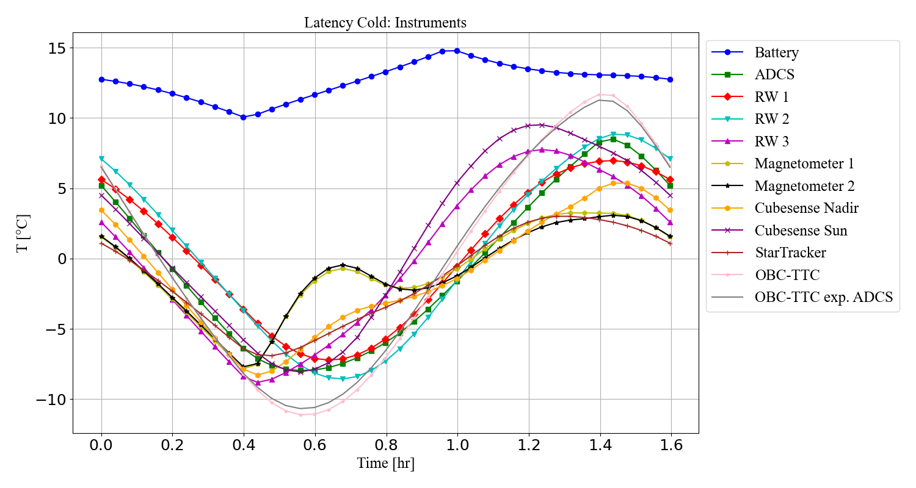

Figure 10: Temperature of instruments in latency ops. mode.

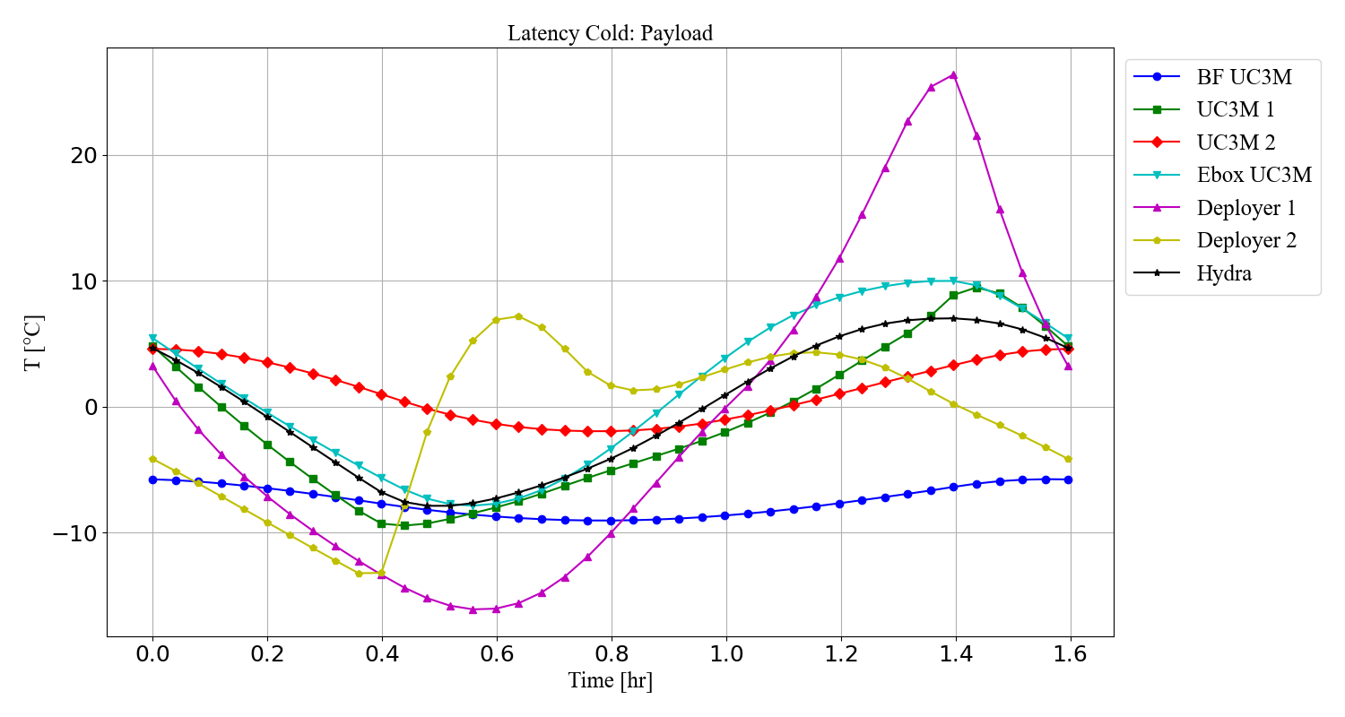

Figure 11: Temperature of payloads in latency operations mode

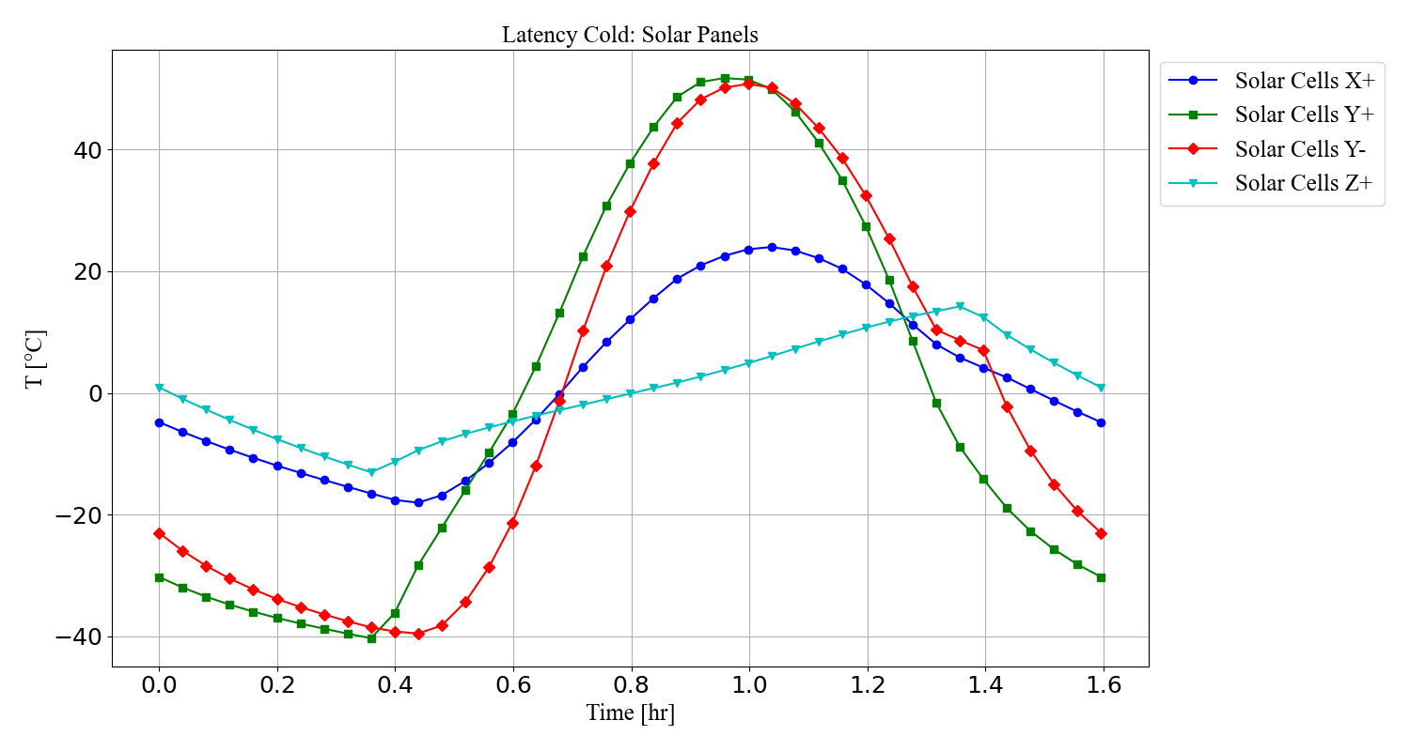

Figure 12: Temperature of Solar Panels in latency ops. mode.

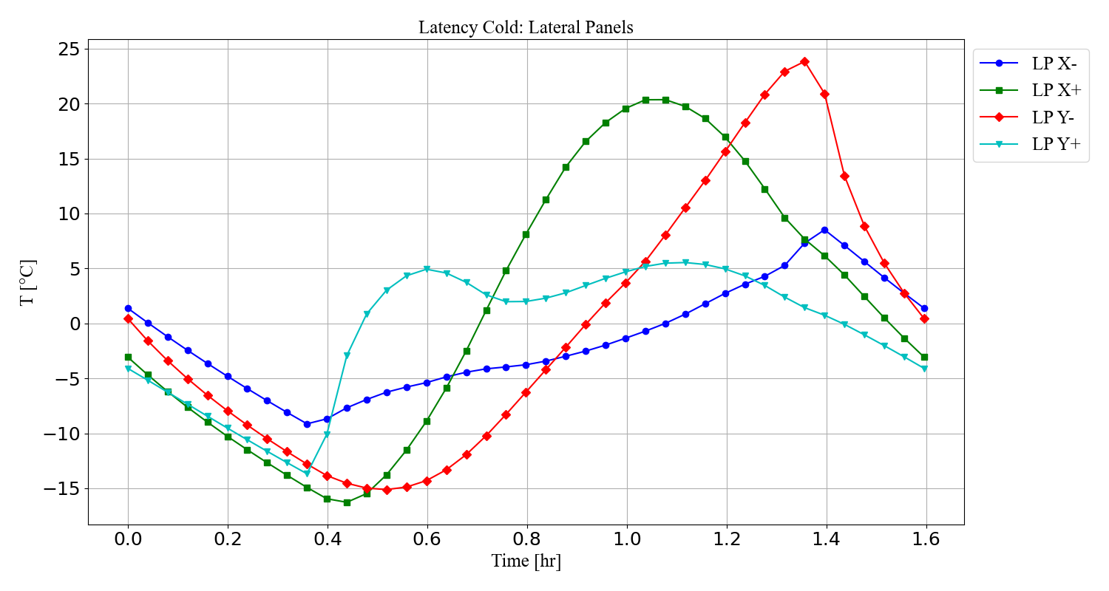

Figure 13: Temperature of Lateral panels in latency ops. mode.

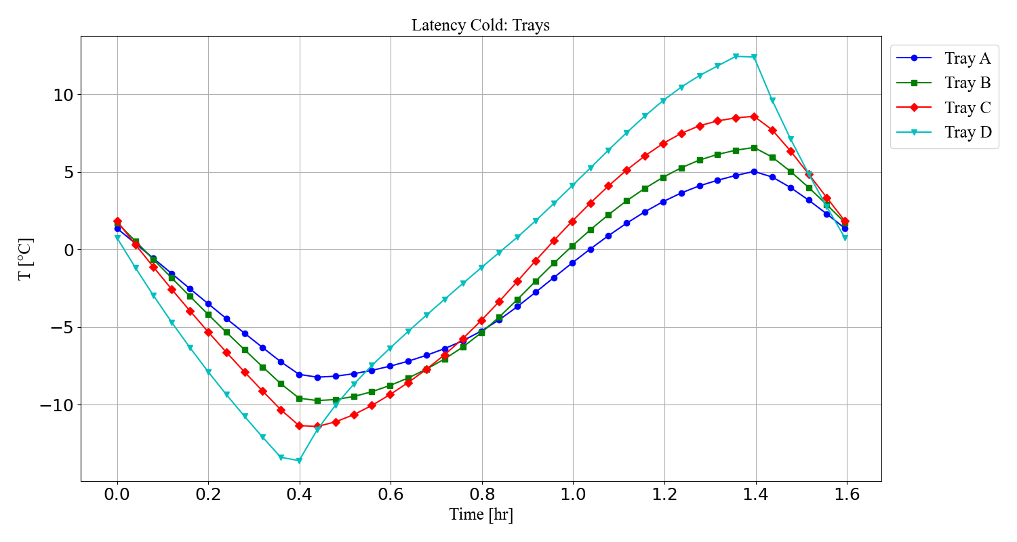

Figure 14: Temperature of Trays in latency ops. mode.

## Nominal

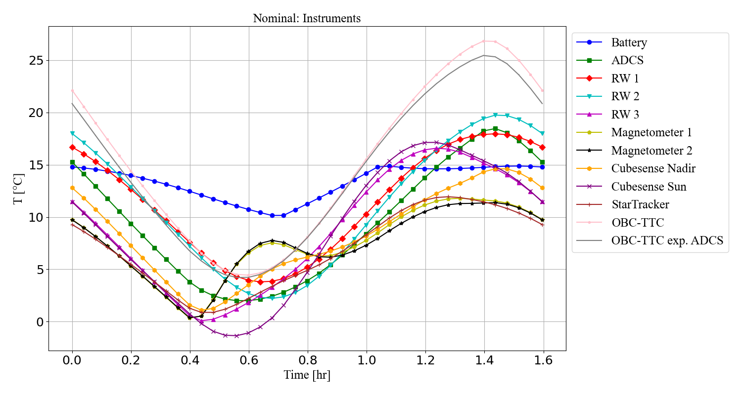

Figure 15: Temperature of instruments and payloads in nominal ops. mode.

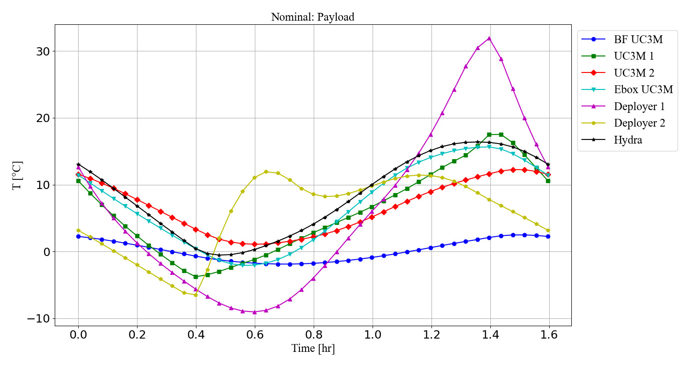

Figure 16: Temperature of payloads in nominal operations mode

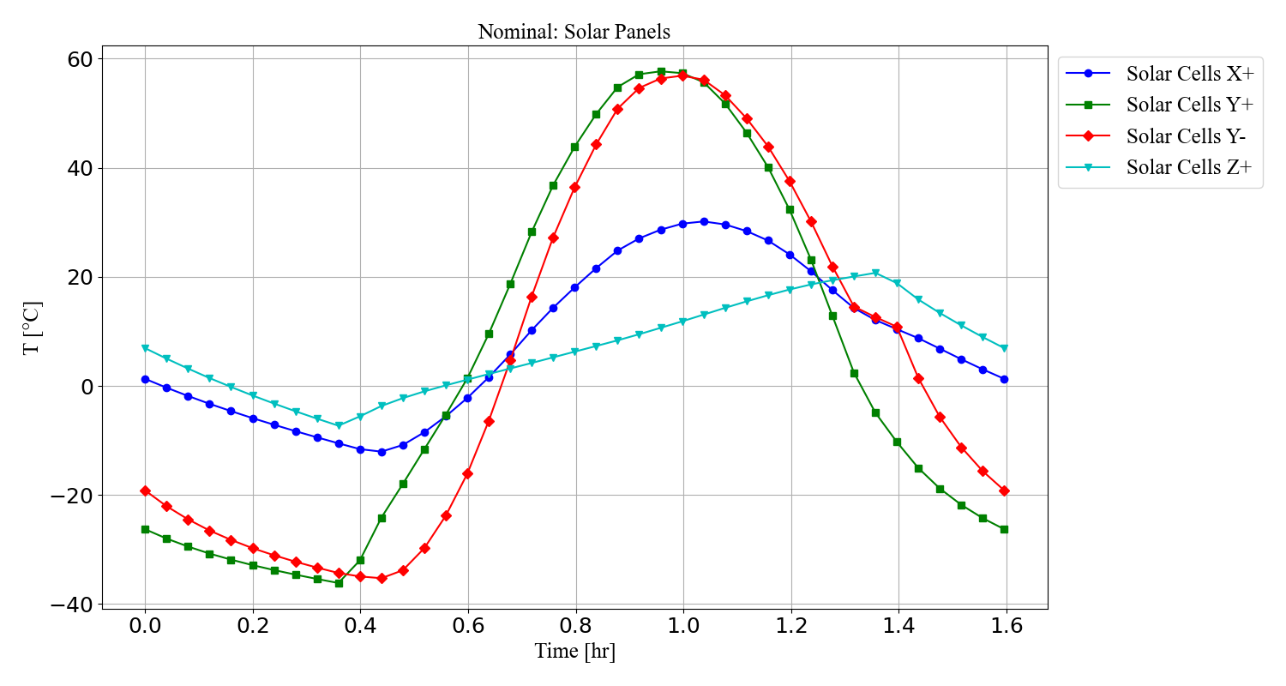

Figure 17: Temperature of Solar Panels in nominal ops. mode.

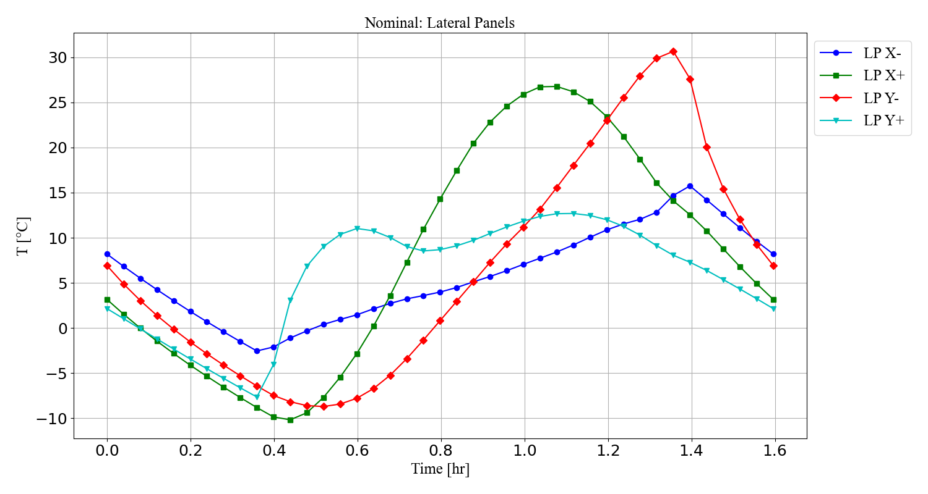

Figure 18: Temperature of Lateral Panels in nominal ops. mode.

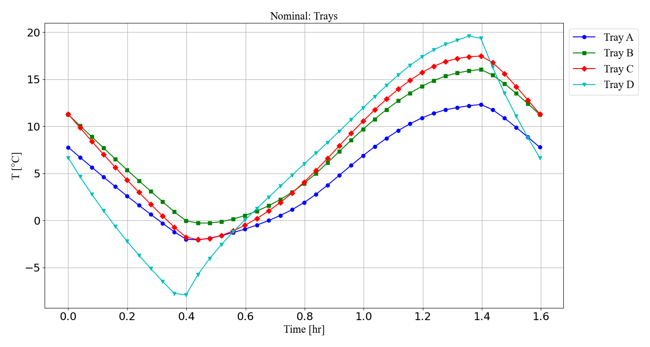

Figure 19: Temperature of Trays in nominal ops. mode.

## Payload 1

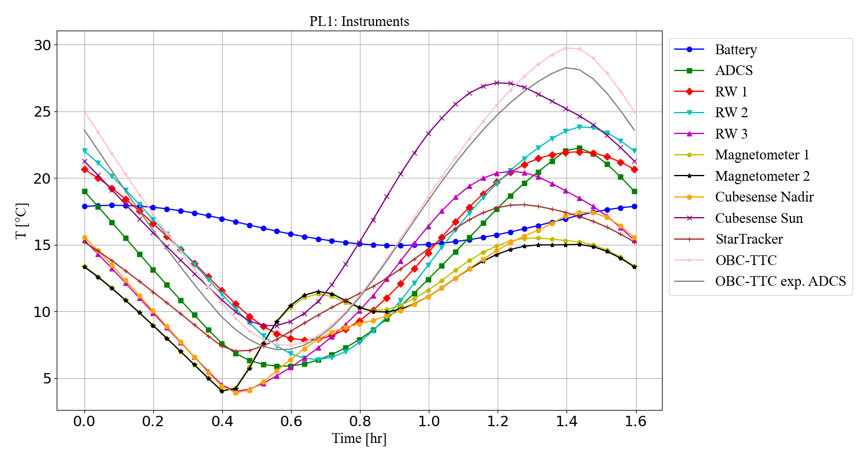

Figure 20: Temperature of instruments in payload 1 ops. mode.

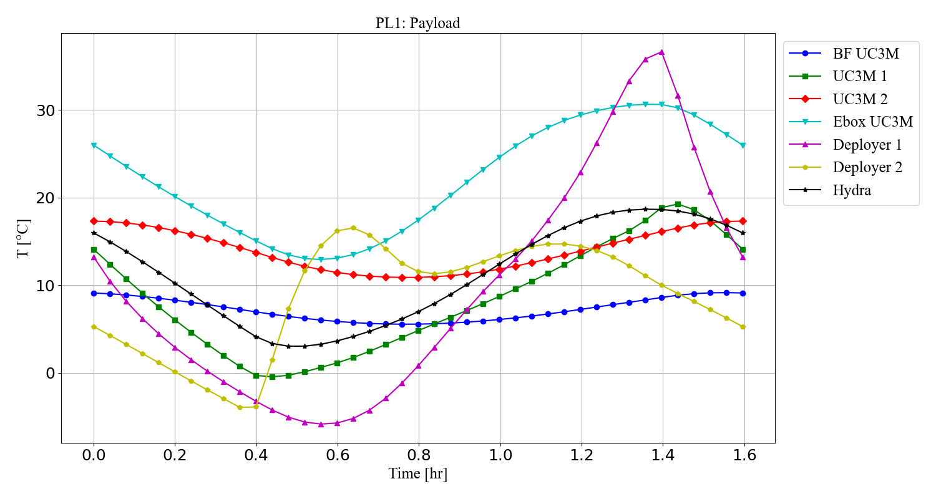

Figure 21: Temperature of payloads in payload 1 ops. mode.

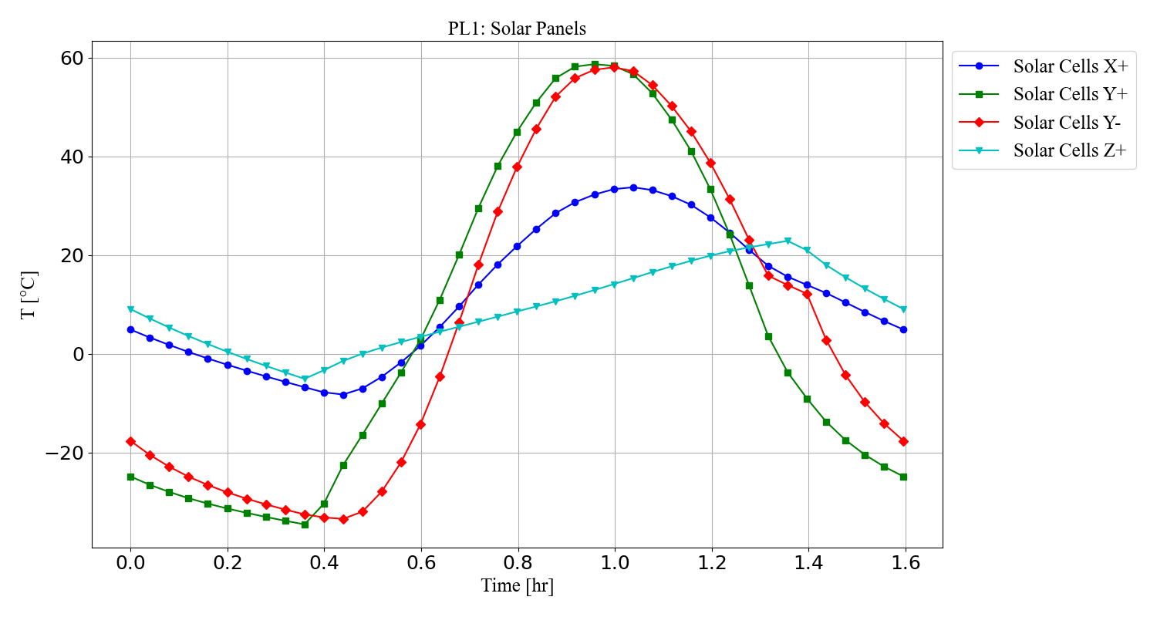

Figure 22: Temperature of Solar Panels in payload 1 ops. mode.

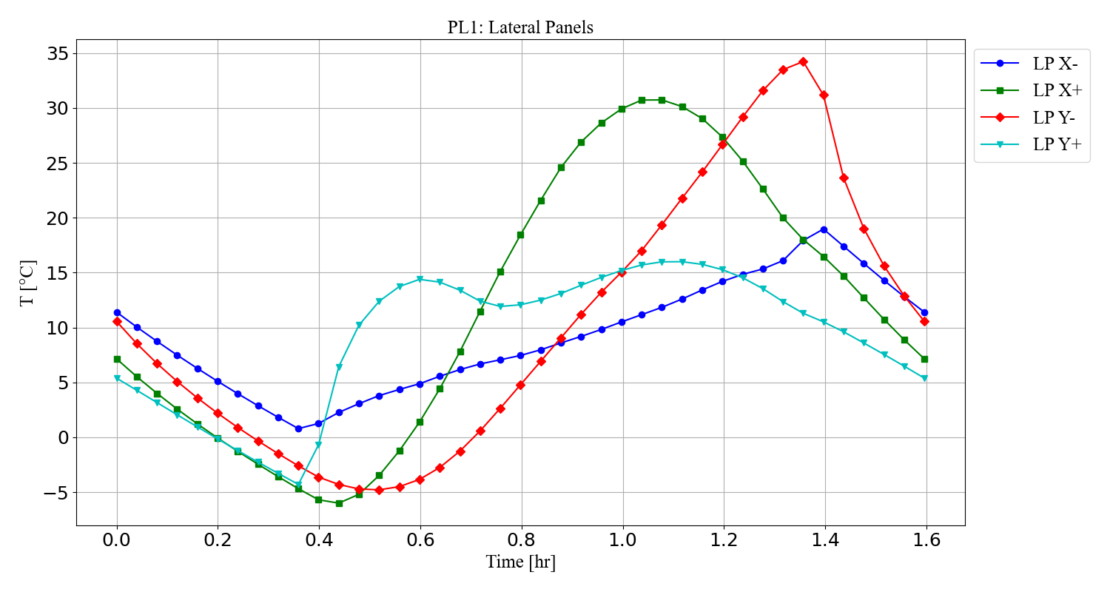

Figure 23: Temperature of Lateral Panels in payload 1 ops. mode

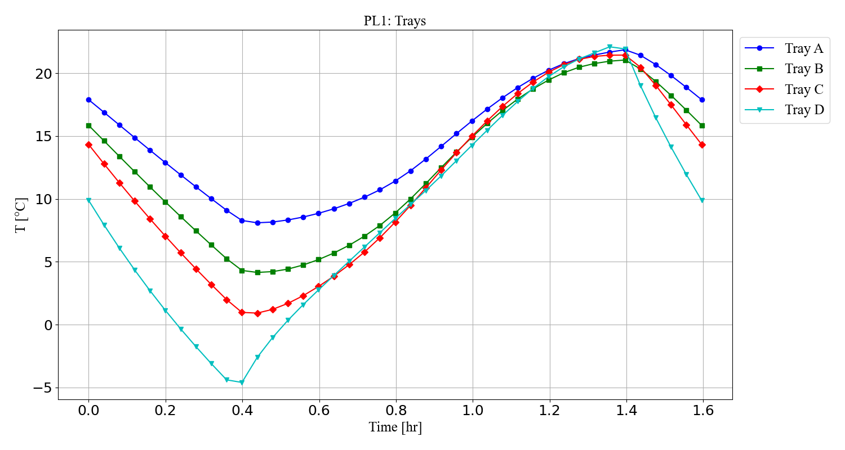

Figure 24: Temperature of Trays in payload 1 ops. mode.

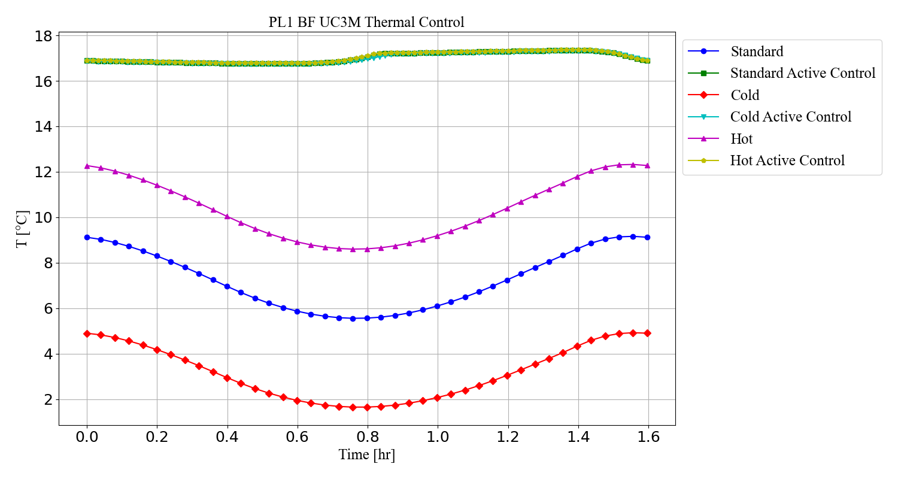

Figure 25: Comparison of radiative cases with BF-UC3M.

## Payload 2

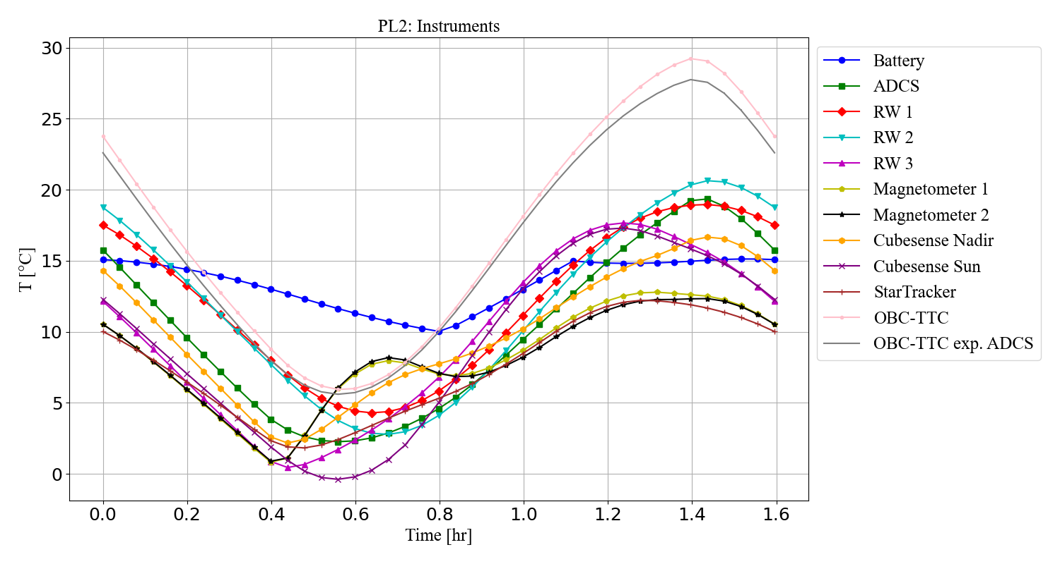

Figure 26: Temperature of instruments in payload 2 ops. mode.

Figure 27: Temperature of payloads in payload 2 ops. mode.

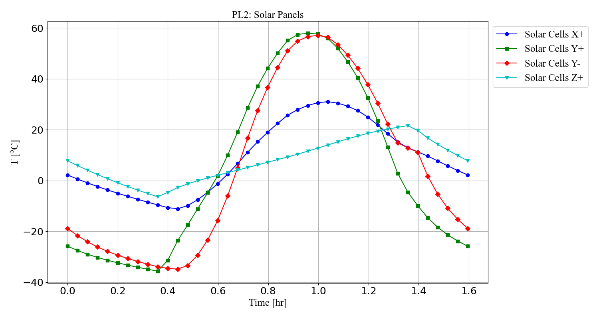

Figure 28: Temperature of Solar Panels in payload 2 ops. mode.

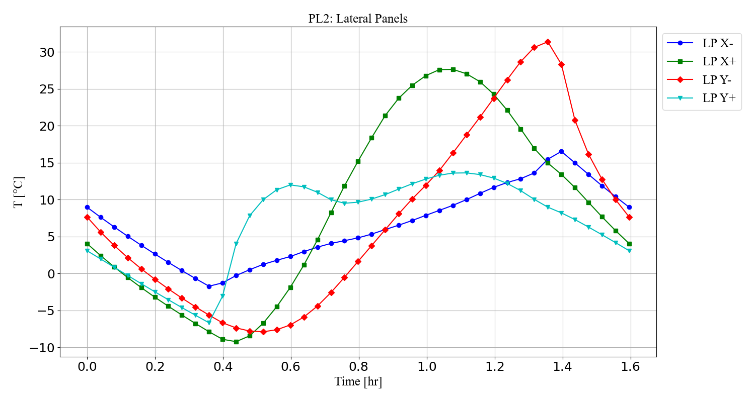

Figure 29: Temperature of Lateral Panels in payload 2 ops. mode.

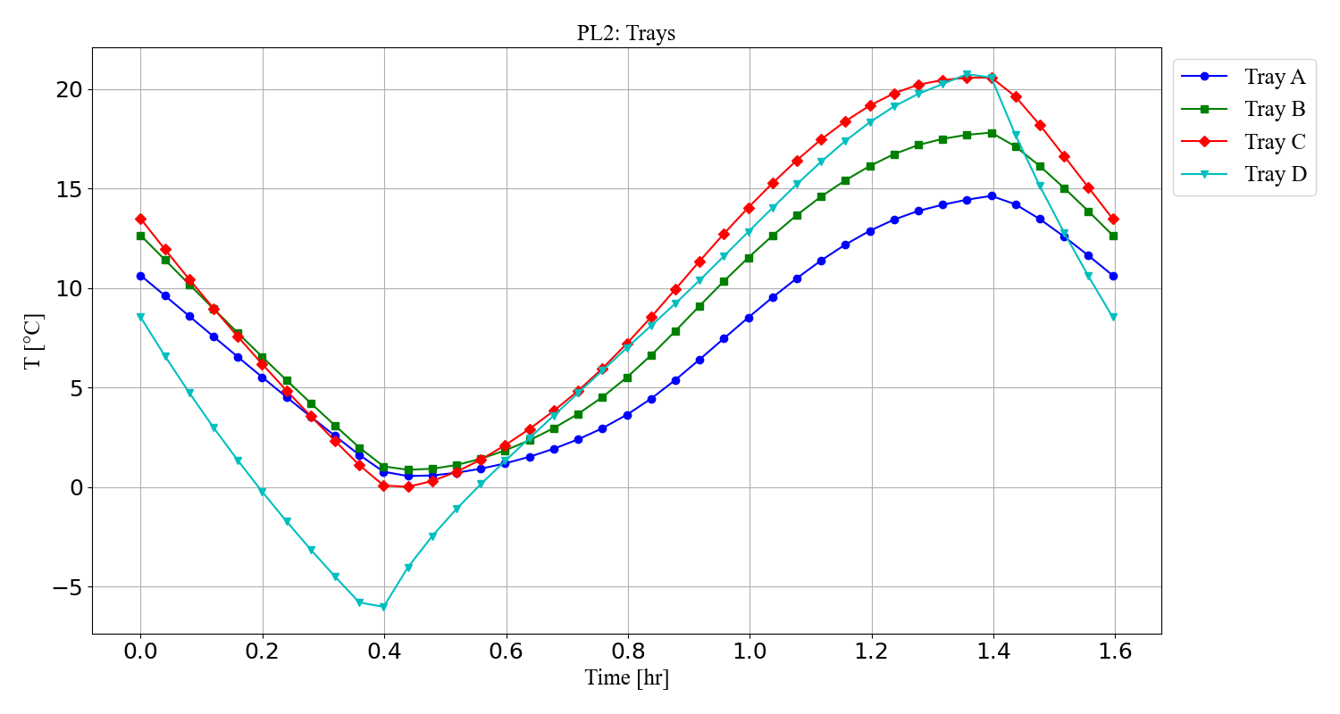

Figure 30: Temperature of Trays in payload 2 ops. mode.

## Safe

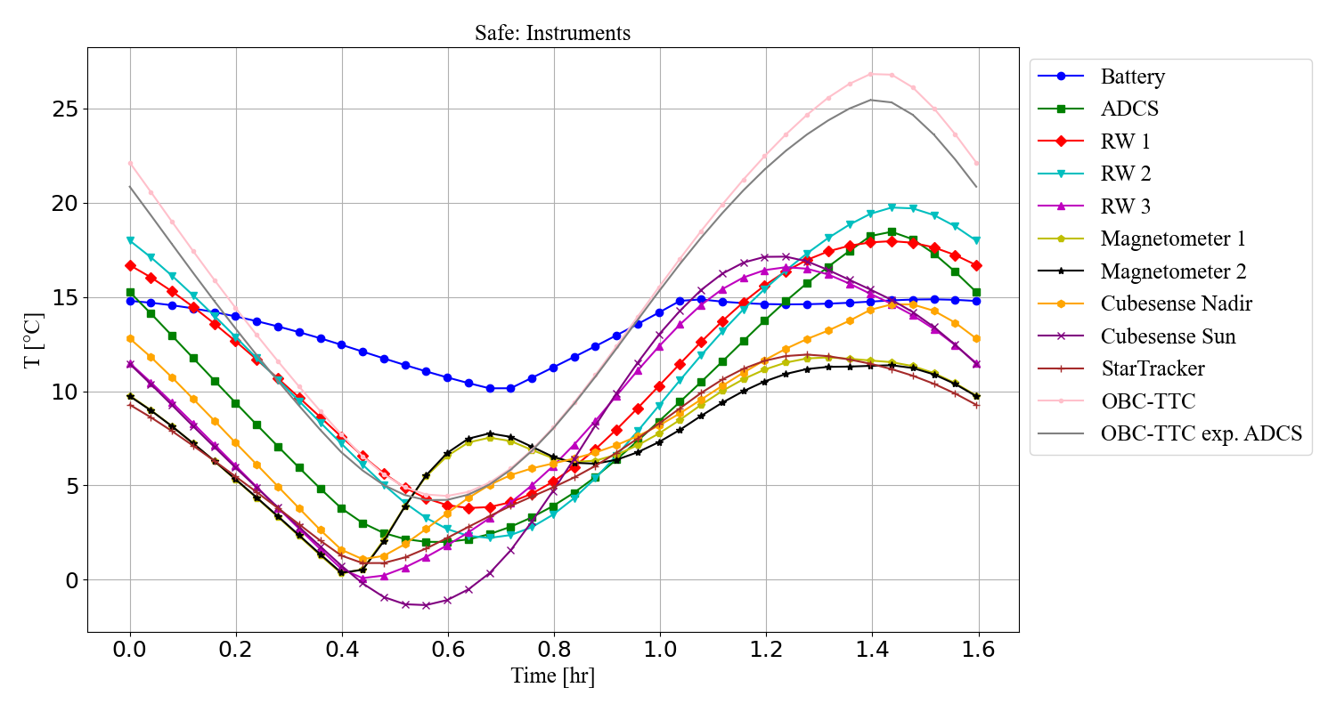

Figure 31: Temperature of Instruments and payloads in safe ops. mode.

Figure 32: Temperature of Instruments and payloads in safe ops. mode.

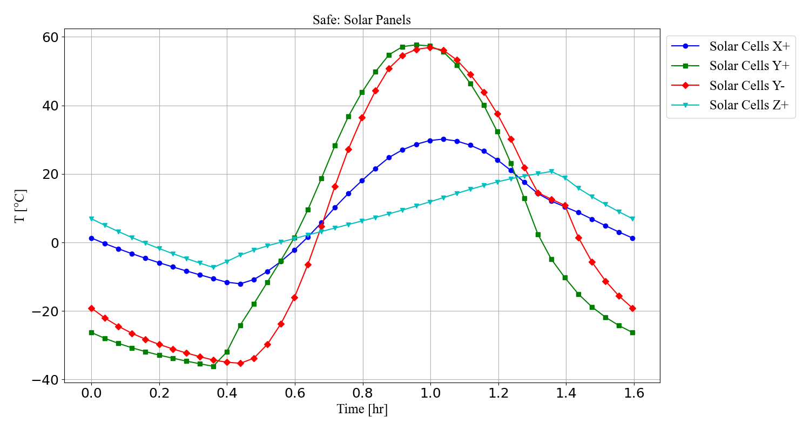

Figure 33: Temperature of Solar Panels in Safe ops. mode.

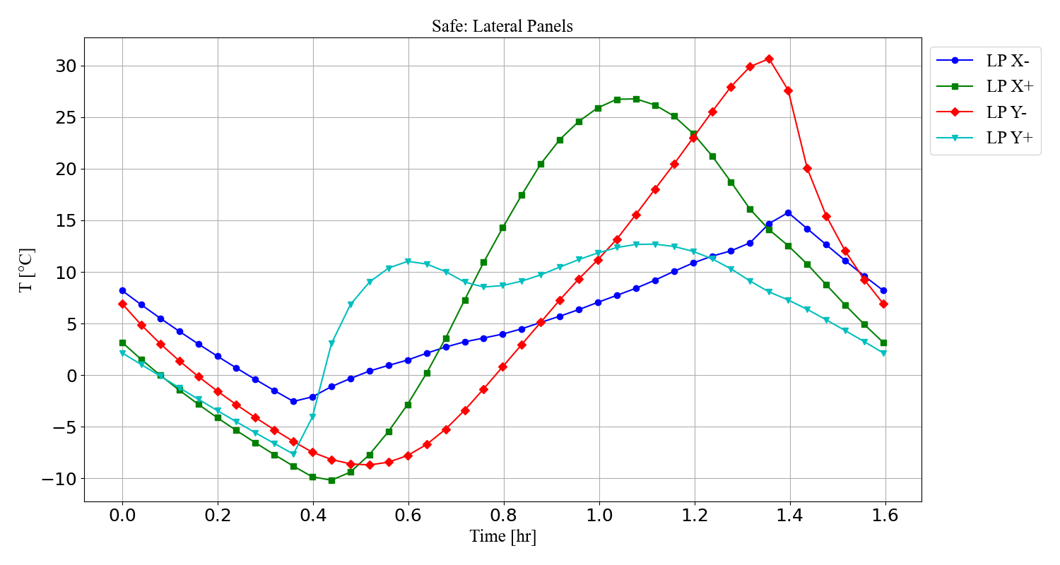

Figure 34: Temperature of Lateral Panels in Safe Ops. mode.

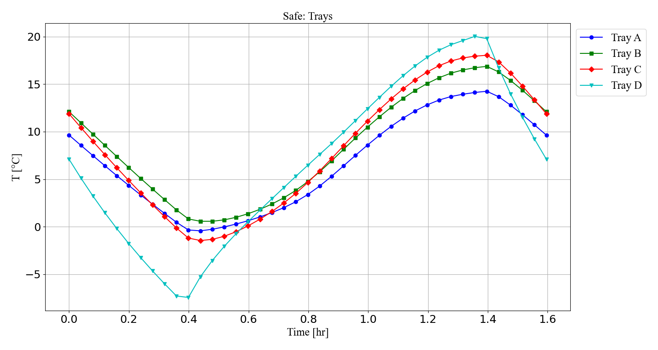

Figure 35: Temperature of Trays in Safe ops. mode.

## Battery comparison cases

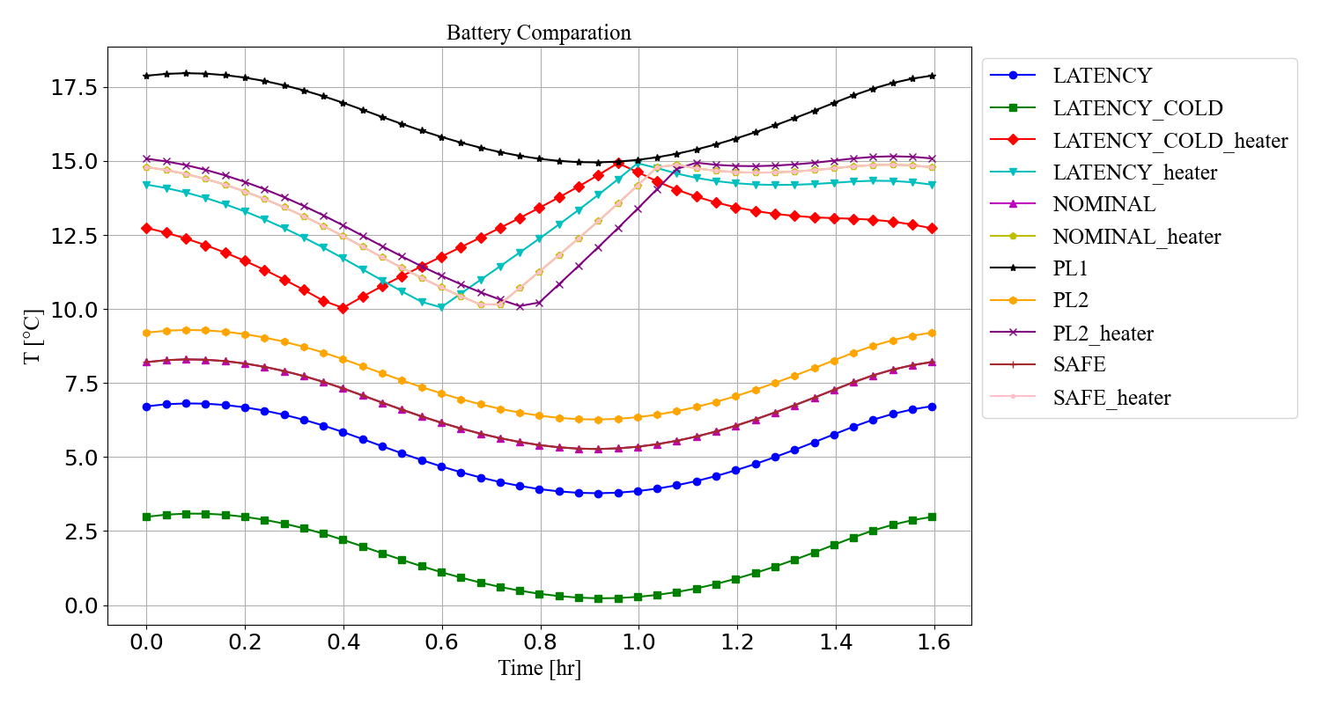

Figure 36: Battery comparison cases.

# Components Temperature Range

Table 8: Operational and Survival temperature range.

|  |  |  |  |
| --- | --- | --- | --- |
| Subsystem | Item | Operational Temp. range (°C) | Survival Temp. range (°C) |
| ADCS | Computer | $-$ 10 to 70 | TBD |
| Interface Module | $-$ 10 to 70 | TBD |
| Magnetotorquer 1 | $-$ 20 to 70 | TBD |
| Magnetotorquer 2 and 3 | $-$ 20 to 70 | TBD |
| PC104 | $-$ 10 to 60 | TBD |
| Startracker | $-$ 10 to 60 | $-$ 40 to 85 |
| Shrinkwrap | $-$ 40 to 125 | TBD |
| Magnetometers | $-$ 20 to 70 | $-$ 20 to 70 |
| CubeSense | $-$ 20 to 70 | TBD |
| OBC | CubeComputer | $-$ 10 to 70 | TBD |
| A3200 | $-$ 30 to 85 | $-$ 30 to 85 |
| TTC | NanoCom AX100 | $-$ 30 to 85 | $-$ 30 to 85 |
| Payload | Hydra | TBD | $-$ 30 to 60 |
| UC3M Radiometers | 16 to 18 | $-$ 40 to 85 |
| $-$ 40 to 50 |
| $-$ 60 to 85 |

# GL scheme

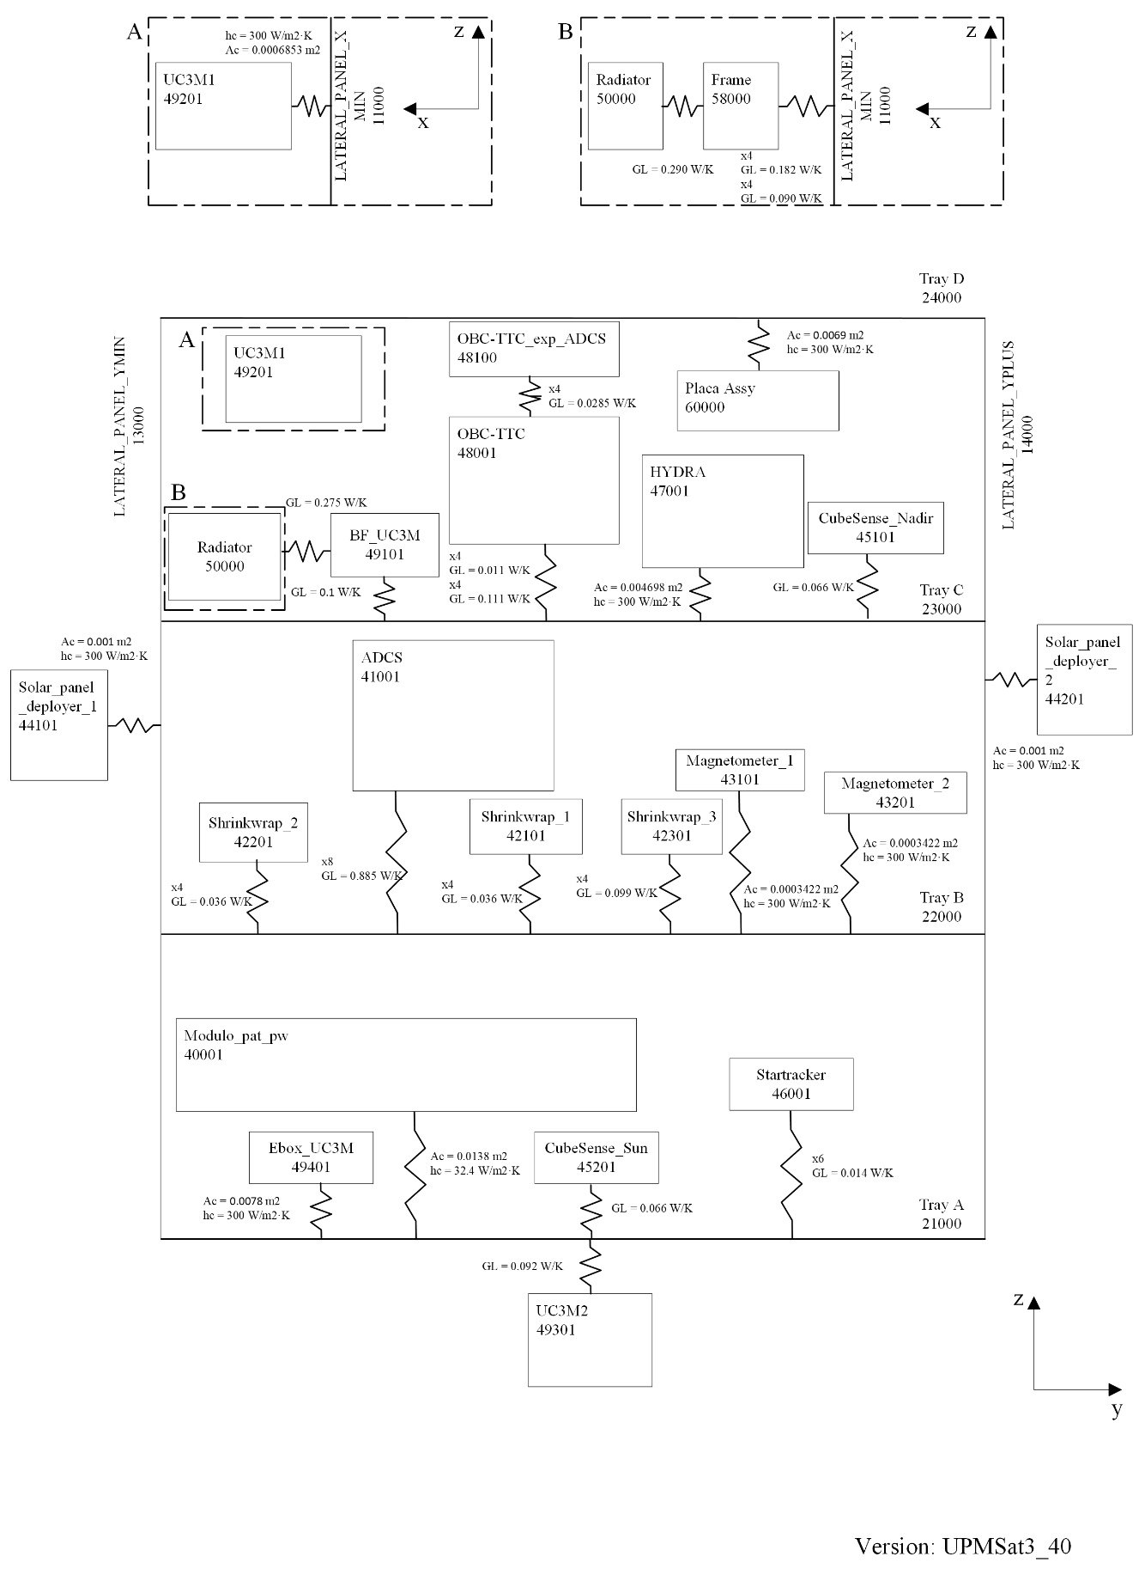

Figure 37: GL scheme of the UPMSat-3 ESATAN-TMS model.

1. Corrected by efficiency of AzurSpace Solar cell .